Early Game
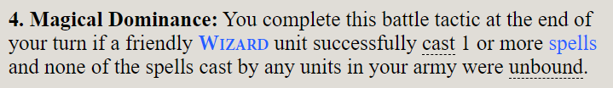
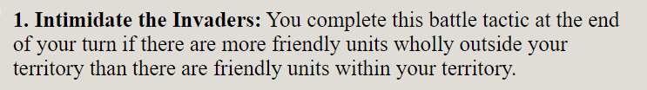
Mid Game
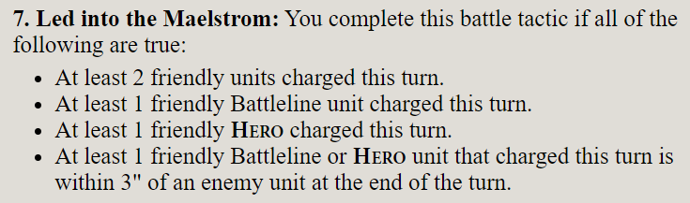
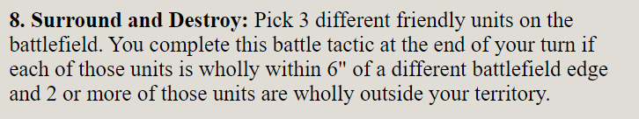
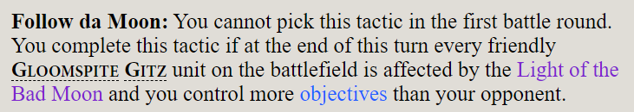
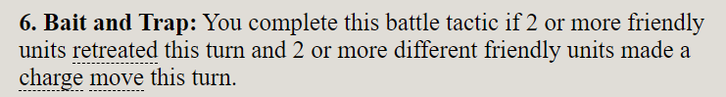
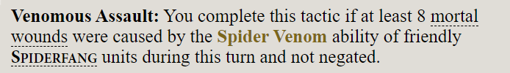

Stealing Objectives
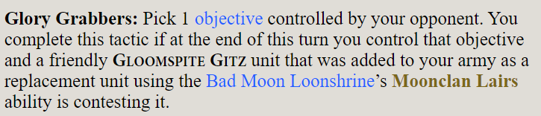
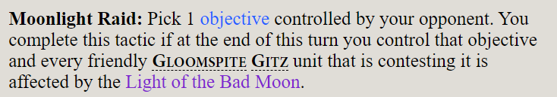
Killing
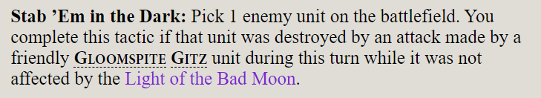
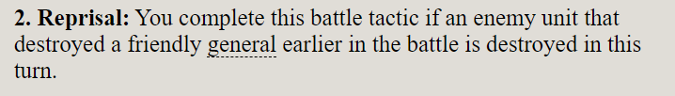

Wizard Hunters: Loonboss, Stabbas, Blue Skitter, Sporesplattas
Triumph: 1990
Intimidate: Start with 14 units, need 8 outside
6 can be with Skitters, so need 2 more
Master of Magic: Deploy Hoarfrost wizard back but near A-Rok.
Cast Scuttletide.
Skitters: Need 6x units total on missions 3 and 5
Spider Riders plus 1 more each
Options: Scuttleboss, Shammy x2, Warparty x2

